Leinster School of Music and Drama

Theory Examination Paper

Preparatory Grade

Summer 2013

Name:- ________________________________

Reference:- ___________________________

All questions should be attempted.
Please write your answers in this booklet

Duration:- 1 hour

Question | Maximum Mark |  | Mark Awarded
1 | 10
2 | 10
3 | 10
4 | 20
5 | 10
6 | 10
7 | 30
Total | 100

Question 1 (10 Marks)

Write the letter names of each of the following notes in the space provided

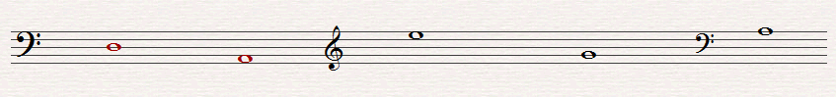 _____ _____ _____ _____ _____

Question 2 (10 Marks)

Write the following notes as Minims (Half notes)

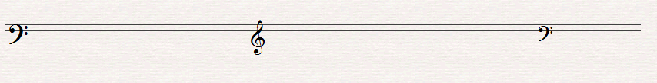
G in a space D on a line F in a space D on a line C in a space

Question 3 (10 Marks)

Insert the correct Clef before each of these notes to make the letter name fit

C B G G B

Question 4 (20 Marks)

Write the letter name and time value of each of the following notes. (i.e. C, 1 beat)

Letter ______ _______ _______ _______ _______

Time _______ ______ _______ _______ ______

Question 5 (10 Marks)

Fill in the missing Time Signatures before each of the following extracts

(a)
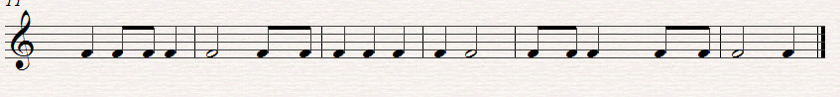
(b)

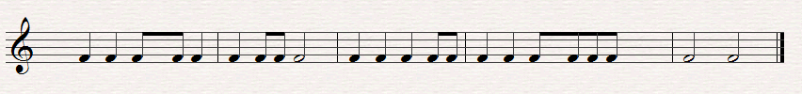

Question 6. (10 Marks)

Put one note only at each Asterix to make the time signature correct

(a)
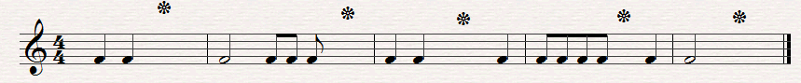

(b)

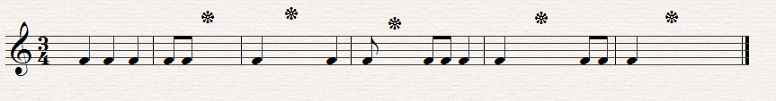

Question 7.

Answer the Questions on the following Piece of Music. All of the answers are found in the extract.

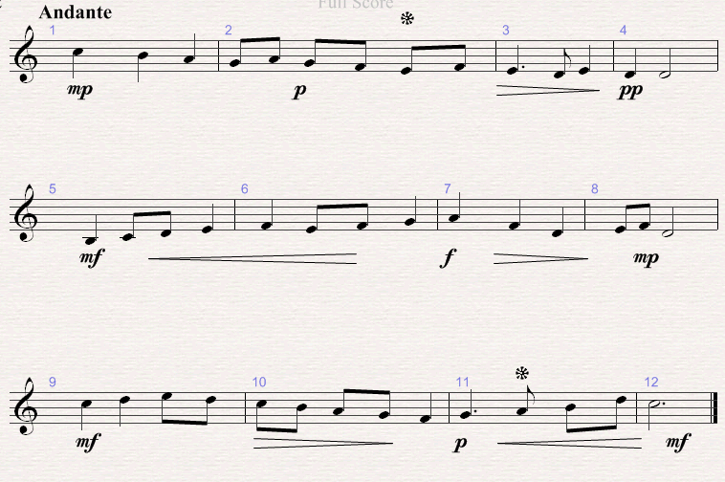

(a)
(10 Marks)

Put in the correct time signature at the start of the extract?
Is the time signature Duple or Triple? ___________________________
What type of clef is used? ________________________________________
Which is the loudest bar in the piece? ____________________________
Which is the softest bar in the piece? _____________________________

(b) (10 Marks)
What does f mean? _________________________________________________
What does p mean? _________________________________________________
What does mf mean _______________________________________________
Name the note marked * in Bar 2 ___________________________________
What is the value of the note marked * in Bar 11 _______________________

( c) (10 Marks)

Copy out the last four bars in the clef, time-signature and any directions given.

Leinster School of Music and Drama

Theory Examination Paper

Grade 1

Summer 2013

Name:- ________________________________

Reference:- ___________________________

All questions should be attempted.
Please write your answers in this booklet

Duration:- 1 hour and 30 minute

Question | Maximum Mark |  | Mark Awarded
1 | 10
2 | 10
3 | 10
4 | 10
5 | 10
6 | 10
7 | 10
8 | 30
Total | 100

Question 1. (10 Marks)
(a) Write the letter names of each of the following notes in the space provided

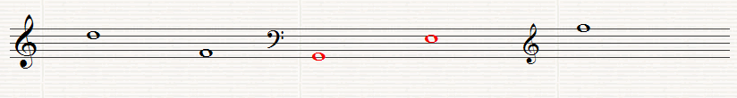 ______ ______ ______ ______ ______

(b) write the following notes as crotchets (Quarter notes)

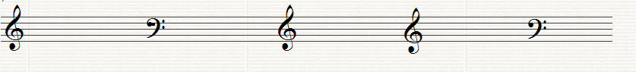

C in a space F on a line B on a line F in a space A in a Space

Question 2. (10 Marks)

Write the letter names (including sharp, flat or natural) and the time name of each of the following notes (i,e. C#, quaver)

Letter ___ _____ ______ _____ ______

Type _____ ____ ______ _____ _____

Question 3. (10 Marks)

(a) Fill in the missing Time Signature before each of the following extracts

(i)

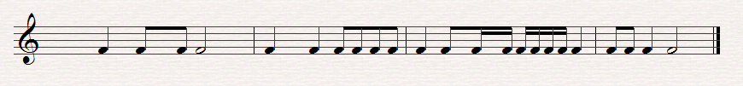
(ii)

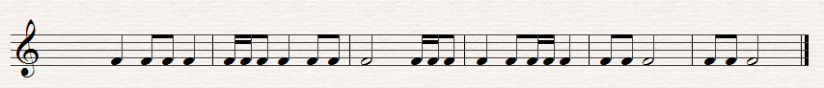

(b) Put one note only at each asterix to make the time-signature correct

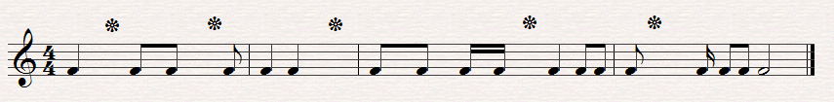

(c) Put one rest only at each asterix to the make the time signature correct

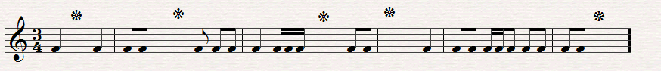

Question 4. (10 Marks)

(a) Re-write this extract grouping the notes correctly according to the time signature

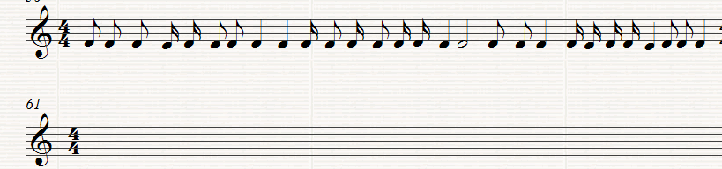

(b) Add the missing Bar lines to the following extract

(i)
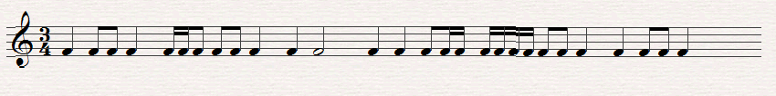
(ii)

(c) Add two more bars to this opening rhythm

Question5. (10 Marks)

(a) Write the scale of F major, ascending without Key-signature, inserting any accidentals that are necessary. in the given Clef in Minims (Half notes). Mark the semi-tones with a slur.

(b) Write the scale of D major descending with key signature, in the given Clef in Semi Breves (Full notes). . Mark the semi-tones with a slur

Question 6. (10 Marks)

(a) Write the tonic triads of the following keys using key-signatures

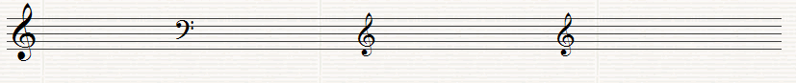

D major C major F major G major

(b) Name the Intervals (by number only) using the bottom note as the tonic (key note)

______ ______ _______ _____ _____

Question7. (10 marks)

Name the degrees of the Scale of the following notes, all taken from the Key of D major

_____ _____ ____ _____ _____ ______

Question 8.
Answer the questions on the following Piece of Music. All answers can be found in the extract

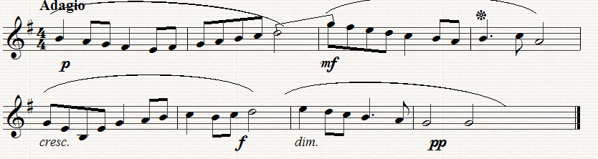

(a) (10 Marks)
What is the Key of the extract?_______________________________
What does Adagio mean?_____________________________________
How many bars are there in the extract? __________________________
What are the long curved lines over the notes known as? _____________
Which degree of the scale does Bar 6 begin on? ____________________

(b) (10 Marks)
Which bar is the loudest? __________________________________
What does mf mean? ________________________________________
What does cresc mean?___________________________________
How many beats does the note in Bar 4 marked*get?__________________
What is the interval (by number only) between the last note in Bar 2 and
the first note in Bar 3 ______________________________________

(c) (10 Marks)
Copy out the melody from Bar 5 to the end inserting the clef, key-signature, time-signature and any directions needed. Marks will be awarded for neatness and accuracy.
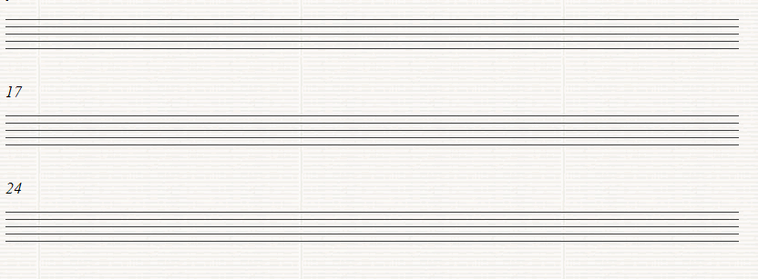

Leinster School of Music and Drama

Theory Examination Paper

Grade 2

Summer 2013

Name:- ________________________________

Reference:- ___________________________

All questions should be attempted.
Please write your answers in this booklet

Duration:- 1 hour and 30 minute

Question | Maximum Mark |  | Mark Awarded
1 | 10
2 | 10
3 | 10
4 | 10
5 | 10
6 | 10
7 | 10
8 | 30
Total | 100

Question 1. (10 Marks)

(a) Write the letter names of each of the following notes in the space provided

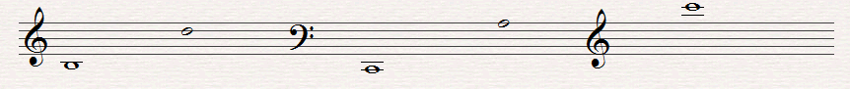
_____ _____ _____ _____ _____

(b) Write the following notes as Crotchets (Quarter notes)

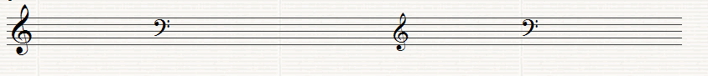
G in a space F on a line C in a space F on a line A on a line

Question 2. (10 Marks)

(a) Write the equivalent rests beside the following notes

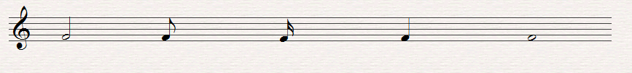

(b) Fill in the missing Time Signature before each of the following extracts

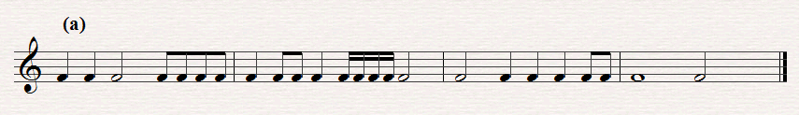

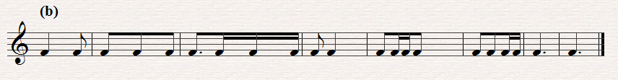

Question3. (10 Marks)
(a) Insert one note only at each asterix to make the time-signature correct

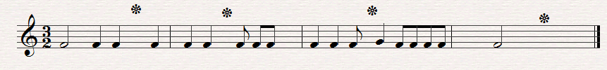

- Put one rest only at each asterix to make the time signature correct

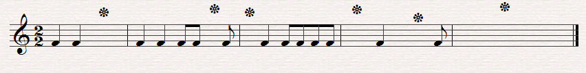

Question 4. (10 Marks)

(a) Re-write this extract grouping the notes correctly according to the time-signature

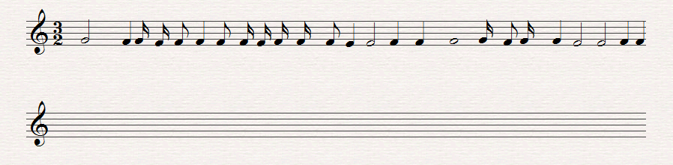

(b) Add the missing bar lines to the following extract

Question 5. (10 Marks)

Use the given opening to make a four-bar rhythm. Use a triplet figure in your answer.

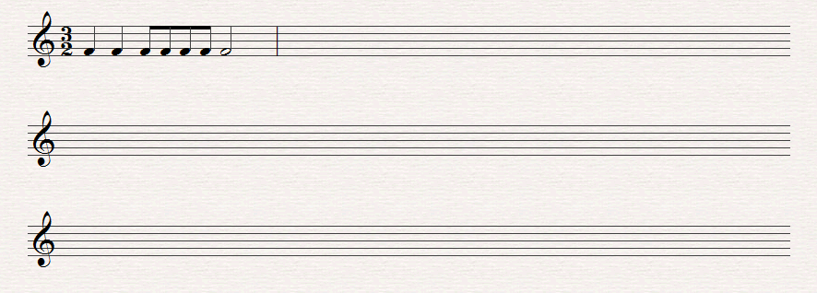

Question 6. (10 Marks)

(a) Write the Scale of E flat major descending with key-signature. Use crotchets and mark the semi-tones with slurs.

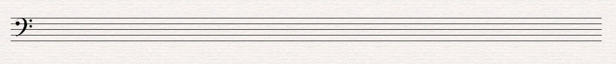

(b) Write the scale of E minor (Harmonic or melodic form), ascending without key-signature. Insert any necessary accidentals. Use crotchets and mark the semi tones with slurs.

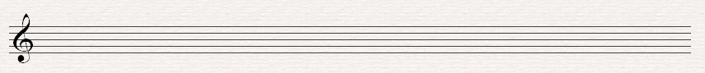

Question 7. (10 Marks)

(a) Write the tonic triads of the following keys without using key-signatures, but adding any necessary accidentals

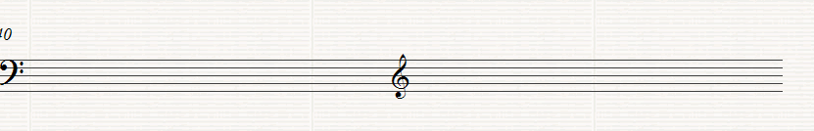
B flat Major E minor

(b) Name these Intervals (by number only) using the bottom note as the tonic (key note)

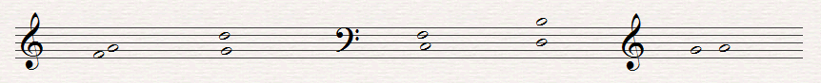
_____ _____ _____ _____ ______

(c) Name the degrees of the scale of the following notes, all taken from the scale of B flat major

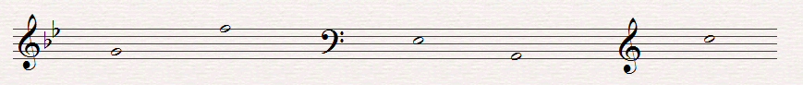
_____ _____ _____ _____ _____

Question 8.

Answer the Questions on the following piece of music. All the answers can be found in the extract.

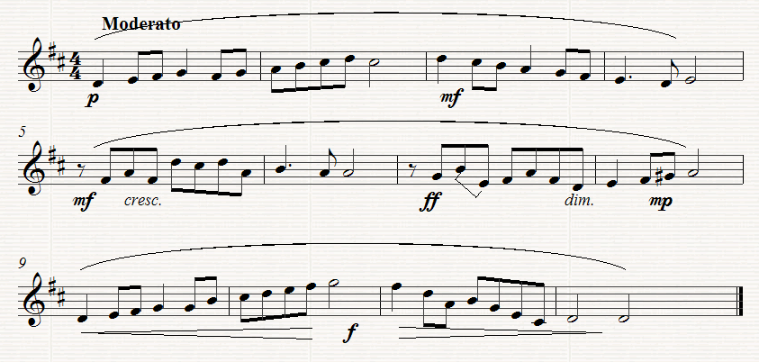

(a) (10 Marks)
(i) What key does the extract begin in? ________________________
(ii) What key does the extract change to in Bar 8 ____________
(iii) What is the Interval between the second two notes in Bar 7 ________________________________________________________________
(iv) What is the letter name of the highest note ___________________
(v) What is the letter name of the lowest note? ___________________
(b) (10 Marks)
(i) What does Moderato mean?_________________________________
(ii) What does cresc mean? ____________________________________
(iii) What kind of rest is used in Bar 5 ___________________
(iv) How many phrases are there in the extract? ________________
(v)Describe what directions are given between bars 9 to 12 ____________________________________________________ _______

(c) (10 Marks)
Copy out from Bar 7 to the end of the extract. Insert the Clef, time-signature, key signature and any other directions needed. Marks will be awarded for neatness.

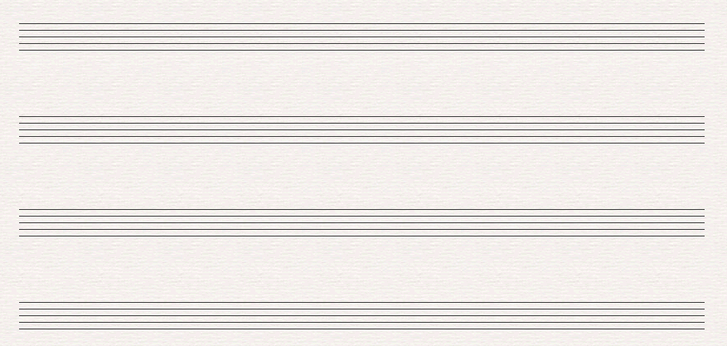

Leinster School of Music and Drama

Theory Examination Paper

Grade 3

Summer 2013

Name:- ________________________________

Reference:- ___________________________

All questions should be attempted.
Please write your answers in this booklet

Duration:- 2 Hours

Question | Maximum Mark |  | Mark Awarded
1 | 10
2 | 10
3 | 10
4 | 10
5 | 10
6 | 10
7 | 10
8 | 30
Total | 100

Question 1 (10 marks)

Add the missing bar-lines to each of the following extracts which all begin on the first beat of the bar

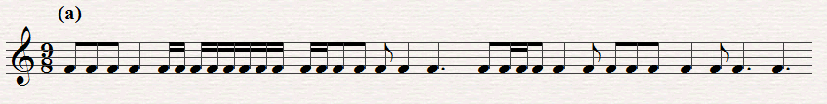

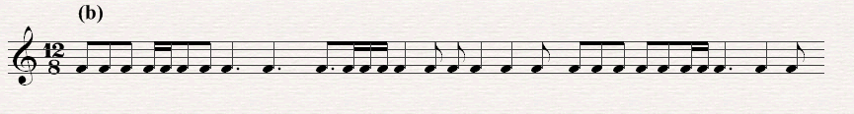

Question 2. (10 Marks)

Write a four bar rhythm in 9/8 time using the given opening which begins on an up beat.

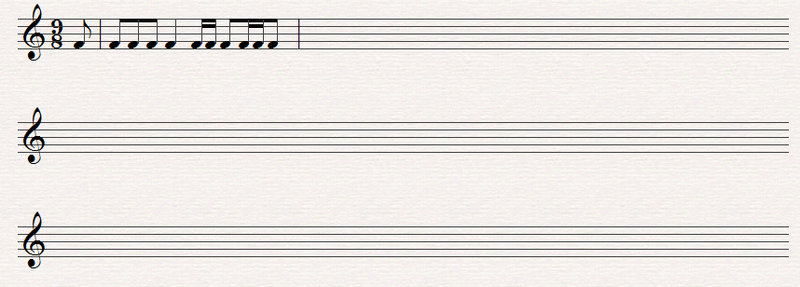

Question 3. (10 Marks)

Rewrite the following with the notes grouped correctly in 9/8 time. Add rests to complete the final bar

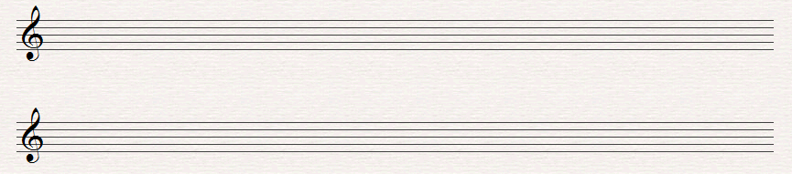

Question 4. (10 Marks)

Write the following scales using the given rhythm

- D sharp Melodic minor, ascending, with key-signature and also including any further accidentals that may be necessary

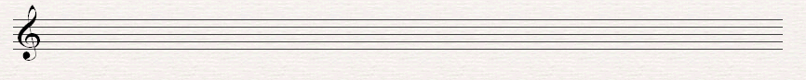

(b) C harmonic minor, descending without using key signature and adding any accidentals that may be necessary

Question 5. (10 Marks)

Write the Key signature and Tonic Triad of each of the following keys.

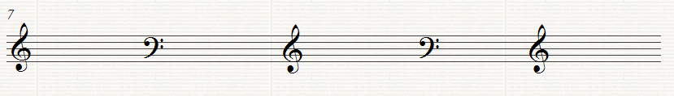

D minor E flat major F major E major A flat major

Question 6. (10 Marks)

Transpose the following melody up an octave. Use the Treble clef as shown

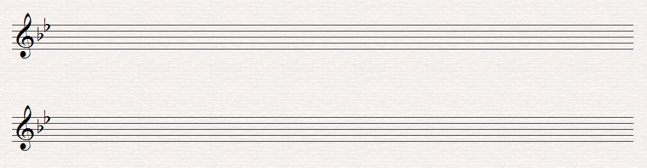

Question 7. (10 Marks)

Above each of the following notes write a higher note to form the named interval. The key is D minor

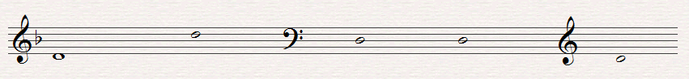

Minor 6th Maj. 2nd Maj. 7th. Minor 3rd. Perfect 5th

Question 8.
This melody is taken from the St. John Passion by Bach. Study the extract and then answer the questions below.

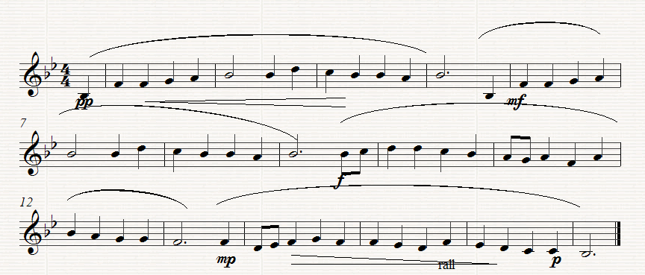

(a) (10 marks)
(I) What is the key of the melody? _____________________________________
(ii) What is the relative minor of this key? _______________________________
(iii) On which degree of the scale does Bar 14 begin?_____________________
(iv) Which note in Bar 10 does not form part of the Tonic triad?__________
(v) How often does the rhythm in the first complete Bar recur? __________

(b) (10 Marks)
(I) Underline one on these Italian terms which you think would suit the direction
Alla Marcia, Largo, Presto
(ii) What does rall mean? ____________________________________________
(iii) What does pp mean? ______________________________________________
(iv) Explain what is meant by the symbol under the notes in bars 14 to the end. ________________ ____________________________________________________

(v)Give the letter names of the highest and the lowest notes ______________

(c) (10 Marks)
Rewrite the melody from the beginning as far as Bar 9 putting it in 2/4 time. Insert the new time-signature

Leinster School of Music and Drama

Theory Examination Paper

Grade 4

Summer 2013

Name:- ________________________________

Reference:- ___________________________

All questions should be attempted.
Please write your answers in this booklet

Duration:- 2 Hours

Question | Maximum Mark |  | Mark Awarded
1 | 10
2 | 10
3 | 10
4 | 10
5 | 10
6 | 10
7 | 10
8 | 30
Total | 100

Question1. (10 Marks)
(a) Add the Time signature and missing bar lines to the following extract.
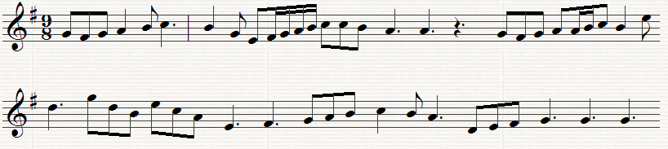

- Re-write the following using notes and rests of double the value. Add the new time signature.

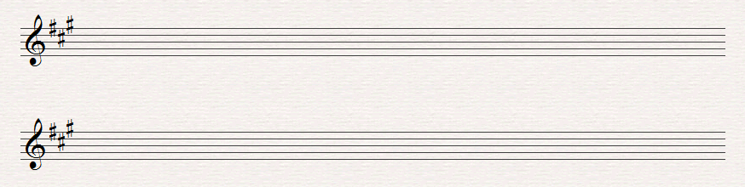

Question 2. (10 Marks)
Either:- Write a rhythm on one note, with the time signature and bar lines, to fit these words. Write each syllable under the note or notes to which it is to be sung.
With hue like that when some great painter dips
His pencil in the glow of earthquake and eclipse (Shelley)
Rhythm _______________________________________________________________
Words……………………………….................................................................
Rhythm________________________________________________________________
Words ………………………………................................................................

OR
(b) Write a four bar rhythm in 9/8 time. Include the following groups of notes in your rhythm

Question 3. (10 Marks)
Name each of the following Notes
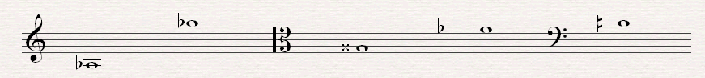
______ ______ ______ ______ _______
Question 4. (10 Marks)

Re-write the following using the Treble Clef but keeping the pitch the same.
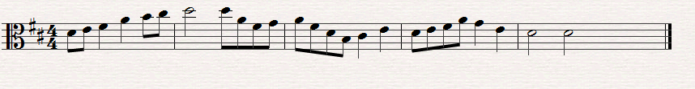

Question 5. (10 Marks)
Write the scales named below, using the following rhythm.

- Write the key signature of 3 sharps and then write the minor scale, melodic form which has that key signature, ascending, using the given clef. Insert any further necessary accidentals

(b) Write the key signature of 4 flats and then write the Harmonic minor scale which has that key signature, ascending using the given clef.

Question 6 (10 Marks)
(a) Write the enharmonic equivalent of the following notes.
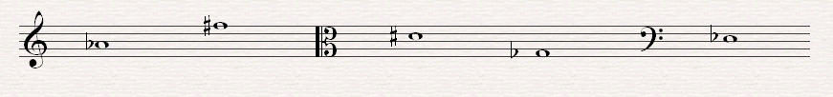
- Write a note above each of the given notes to form the named harmonic interval.

Perfect 5th Major 7th Minor 3rd Augmented 4th Diminished 5th

Question 7. (10 Marks)
(a) Name each of the numbered chords as Tonic, Subdominant or Dominant.
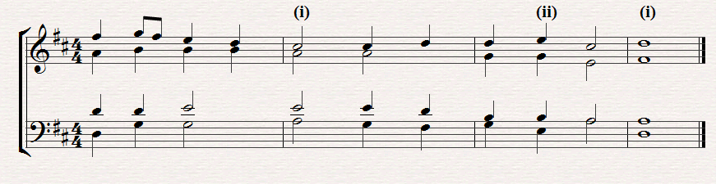
(I) _________ (ii)___________ (iii)_______________
(b) Write the named triads, as shown by the Key-signature

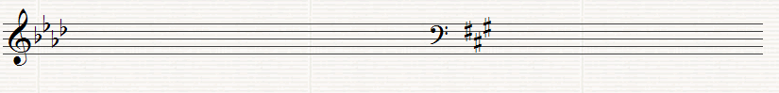
Minor Key Major Key
Dominant Triad Sub Dominant Triad

Question 8.
This is an extract from the first Violin part of the second movement of Haydn’s Symphony No. 92. Study it and answer the following questions

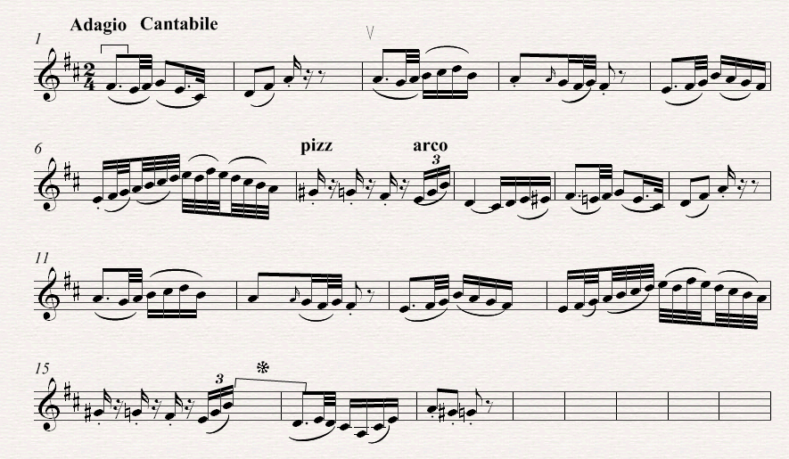
(a) (10 Marks)
Give the meaning of each of the following:-
(i) Adagio Cantabile______________________________________________
(ii) V in Bar 3________________________________________
(iii) in Bar 1 __________________________________________
(iv) How many times does the rhythm in Bar 5 recur ________________
(b) (10 Marks)
(i) What is the Interval between the last note in Bar 15 and the first note in Bar 16_________________
(ii) Assuming the Kay is D major, what chord in that key is formed by the last three notes in Bar 6 . _____________________________
(iii) Assuming that the key is G major what is the technical name of the first note in the extract __________________________________________

(iv) Write Bars 9 to 13 at the same pitch in the Alto Clef.
(v) Re-write bars 1 to 7 using notes and rests twice the value.. Insert the new Time Signature.

(c) (10 Marks)
(i) Name Four Wood wind Instruments:- __________________________________________________________________
(ii) Name the four main Brass wind Instruments __________________
_________________________________________________________________
(iii) What are the four open strings on the ‘Cello___________________
(iv) Name two Transposing Instruments __________________________
(v) Name two Percussion Instruments_____________________________

Leinster School of Music and Drama

Theory Examination Paper

Grade 5

Summer 2013

Name:- ________________________________

Reference:- ___________________________

All questions should be attempted.
Please write your answers in this booklet

Duration:- 2 Hours and 30 minutes

Question | Maximum Mark |  | Mark Awarded
1 | 10
2 | 10
3 | 10
4 | 10
5 | 10
6 | 10
7 | 10
8 | 30
Total | 100

Question 1. (10 Marks)
- In the following extract several changes of Time signature are needed. Insert the time signatures at the appropriate places.

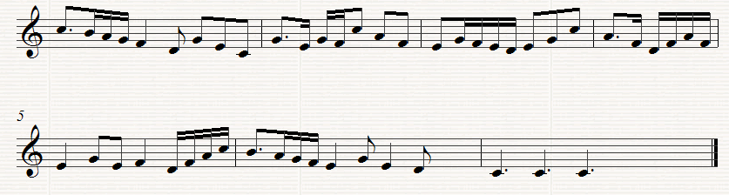

- Re-write the following melody at the same pitch using the Tenor Clef. Insert the appropriate Key signature
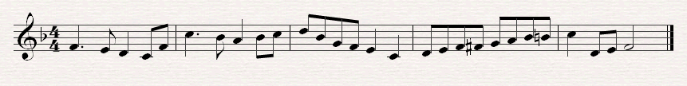

Question 2. (10 Marks)
Re-write the following in open score. Begin as shown..
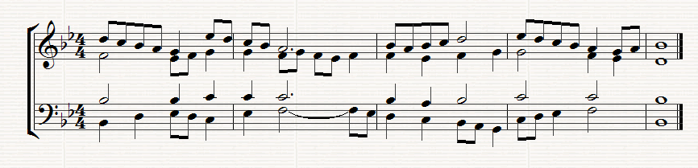
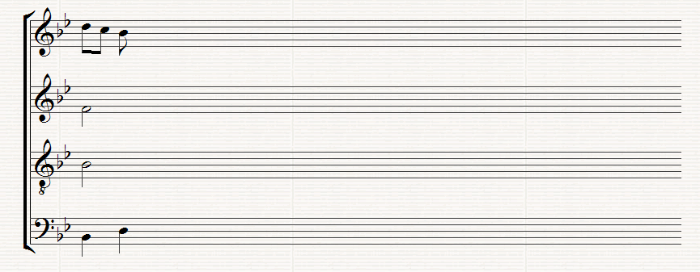

Question 3. (10 Marks)
Re write the following melody for the Clarinet in A by transposing it up a minor 3rd. Insert the appropriate key signature.

Question 4. (10 Marks)
(a) Write the key signature of 3 sharps after the following C Clef and then the ascending and descending melodic minor scale which has that key signature. Insert any accidentals that may be necessary. Write in semibreves
- Write the scale of C sharp major ascending and descending in the following Clef. Do not use a key signature but insert any accidentals that may be necessary
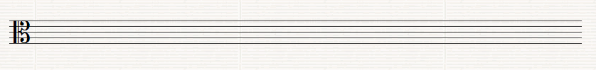
Question 5. (10 Marks)
(a) Write a suitable chord under each of the notes marked *. Use chords I, ii, iv or v or any recognized method of notation
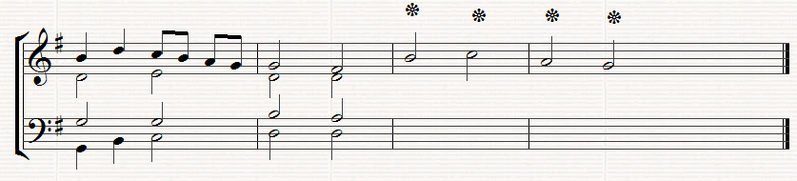
(b) Below the above staves write the progression 6/4,, 5/3 (Chord ic - v) under the two successive chords where this progression occurs
Question 6. (10 Marks)
Above each of the following notes write the named Intervals or Triads requested in the Key of C minor (Harmonic). Do not use a key signature but remember to put in any necessary accidentals which may be necessary. 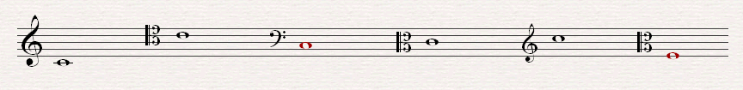
Minor 3rd Perfect 5th Major 7th Tonic Triad Dominant triad Major 2nd

Question 7. (10 Marks) Answer Either A or B
- Write a melody for an Instrument of your choice using the given opening. Add marks for Tempo and Expression and any other performance directions which may be appropriate for the instrument chosen. The complete melody should not be more that 8 bars long
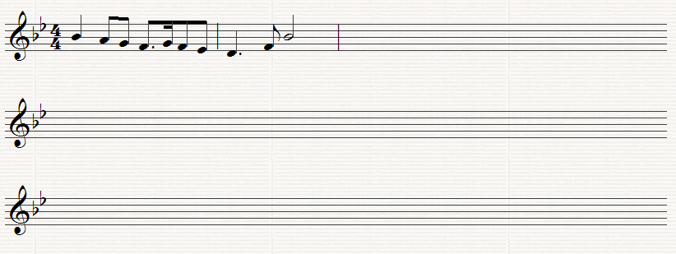
Instrument for which the melody is written ____________________
OR
- Compose a melody to suit the following words. Write each syllable under the note or notes to which it is to be sung.

While the cock with lively din scatter the rear of darkness thin,
And to the stack, or the barn door, stoutly struts his dames before

John Milton

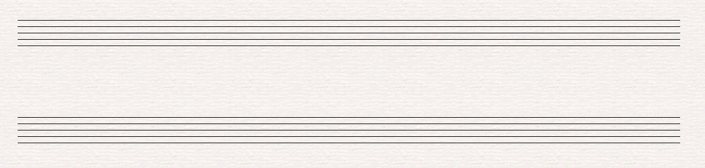

Question 8.
Study the following extract from Scarlatti, Sonata K. 492 for Piano, and answer the following Questions:-
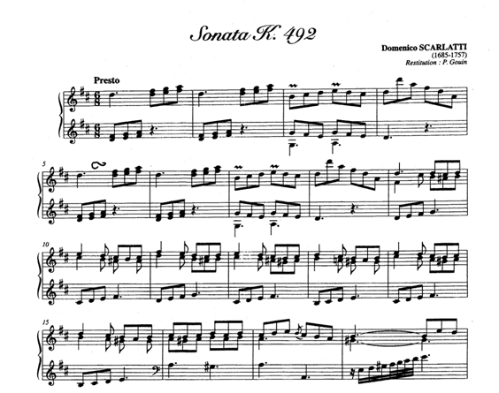
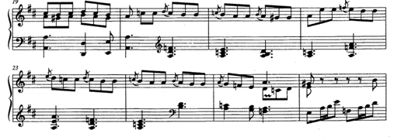

(a) (10 Marks)
Give the meaning of the following
(i) Presto ________________________________________________________
(ii) in Bar 3 _________________________________________
(iii) in Bar 17______________________________________
(iv) in Bar 5 _______________________________________

(v) Write out the note values of the right hand of Bar 23

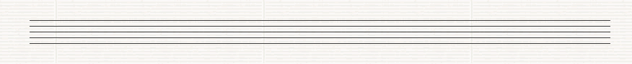

(b) (10 Marks)
(I) Which Wood wind Instrument would be the most suitable to play the first two bars of the Right Hand? _____________________________________________________________________
(ii) What chord is outlined in the second half of Bar 3? _________________
(iii) The key changes in Bar 13. Identify the new key and what relation is that to the original key _________________________________
(iv) What is the Interval between the two notes on the first beat in the right hand in the final Bar?
____________________________________________________
(v) Which Wood wind instrument would be best suited to play the lower notes in the left hand of the last Bar?
________________________________________________

(c) (10 Marks)
Rewrite the left hand part of Bar 18 in notes twice the value. Insert the new time signature

